

Project Star Maroon

Team Name

Version 1.0

|  |  |  |
| --- | --- | --- |
| **Position Title** | **Name** | **Signature** |
|  |  |  |
|  |  |  |
|  |  |  |
|  |  |  |
|  |  |  |
|  |  |  |
|  |  |  |
|  |  |  |
|  |  |  |
|  |  |  |
|  |  |  |
|  |  |  |
|  |  |  |
|  |  |  |
|  |  |  |
|  |  |  |

Instruction: Each team member reviews and signs the completed ASG to treat as a contract. This states that the team member will participate to the level asked of them, be held responsible to all requirements stated here, and be subject to testing of its content. The team should also submit 1 physical copy of the signed cover page each time a version is submitted.

**Document Revisions Table**

|  |  |  |  |
| --- | --- | --- | --- |
| **Version** | **Description** | **Requestor** | **Date** |
| *1.0* | *Initial Document* | *Professor* |  |
|  |  |  |  |
|  |  |  |  |
|  |  |  |  |
|  |  |  |  |
|  |  |  |  |
|  |  |  |  |
|  |  |  |  |
|  |  |  |  |
|  |  |  |  |
|  |  |  |  |
|  |  |  |  |
|  |  |  |  |
|  |  |  |  |
|  |  |  |  |
|  |  |  |  |
|  |  |  |  |
|  |  |  |  |
|  |  |  |  |
|  |  |  |  |
|  |  |  |  |
|  |  |  |  |
|  |  |  |  |

Instruction: The document revisions table provides a location for revision requests and updates. An active role in maintaining this table and meeting the requests of faculty is required.

Table of Contents

Table of Figures 4

Theme Overview 5

Quick Summary 5

Game Art Overview 5

Architecture and Anatomy (ANA) 6

Style Guide 6

Characters 6

Environments 6

Key Objects (Landmarks) 7

Technical Overview 8

Modular Assets 8

Lighting 8

Color 8

Materials/Textures 9

Proportion/Scale 11

Font 12

Asset List 13

Instruction: Generate an automatic Table of Contents. Correct for any bookmark errors and confirm that the CNTRL-click navigates properly.

# Table of Figures

Figure 8: Example of Color Palette 8

Figure 9: Example of Scale Chart 12

Figure 15: Example Environment Concept 7

Figure 16: Example Key Object Concept 9

Figure 17: Example of Font 13

Instruction: Generate an automatic Table of Figures. Correct for any bookmark errors and confirm that the CTRL-click navigates properly.

# Theme Overview

Instruction: Create a Look and Feel Concept image which will define the overall visual style of the game. This will be the primary reference for all assets, lighting, atmosphere, etc. [this can be a painting or an in-game screenshot of some mockup assets, materials, and lighting]

Below the image, put “Figure 1: Look and Feel Concept for [name of your game]”.

## Game Art Overview

Instruction: *Write one paragraph describing the visual style --how it relates to the story, how it relates to the general design of the game. Write another paragraph describing the emotions you want players to feel as a result of your use of this style.*

## Architecture and Anatomy (ANA) -- Style Guide

*NOTE: The goal is a unified style. Be detailed and specific in describing each element.*

### Characters

Instruction: Create a color modelsheet of each major character with all necessary views. Describe the animation style to be used.

### Weapons

Instruction: Create a color modelsheet of each major weapon with all necessary views. Describe the animation style (ifany) to be used.

### Environments

Instruction: How do individual levels differ? Create a minimum of one Look and Feel Concept image per level in the game. This will be the reference for the artists creating the assets and the level designers putting the assets together in that level.

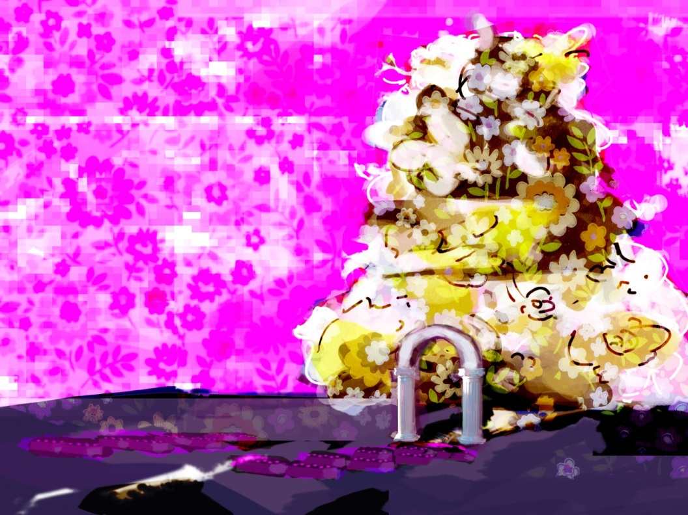

Figure : Example Environment Concept

### Key Objects (Landmarks)

Instruction: Create a modelsheet with all necessary views for each level’s key object(s). This will be the reference for the artist creating the asset(s).

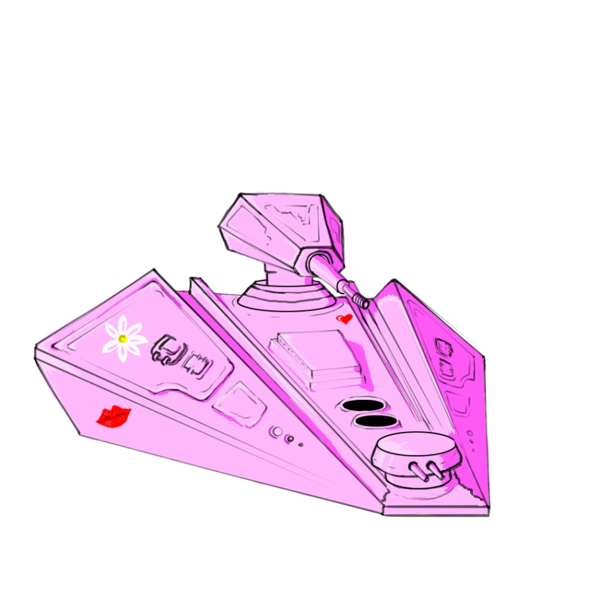

Figure : Example Key Object Concept

## Technical Overview

### Modular Assets

Instruction: The modular assets section fully describes how the set is to be created and used. Include custom color concepts or modelsheets for each major piece.

### Lighting

Instruction: The lighting section fully describes how lights will be used within the game to set and establish the overall mood of the game story and/or individual scene. Fully detail the use of lights and properties that will be made use of to achieve the effects desired. Render the scene from the Reference Level and use the screenshot to illustrate lighting.

### Color

Instruction: The color section identifies a color theme and color palette that the assets and environment will use. This is a purposed choice that must be defined with a reason and explanation of the choices made.

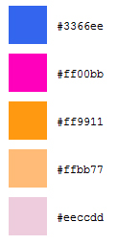

Figure 2: Example of Color Palette

### Materials/Textures

Instruction: Detail the material specifications and texture specifications with samples.

### Proportion/Scale

Instruction: Identify the proportional system you will use within your world. A proportional system is used to build order and believability with the world you create. Developing and maturing the system will provide a consistent and believable world.

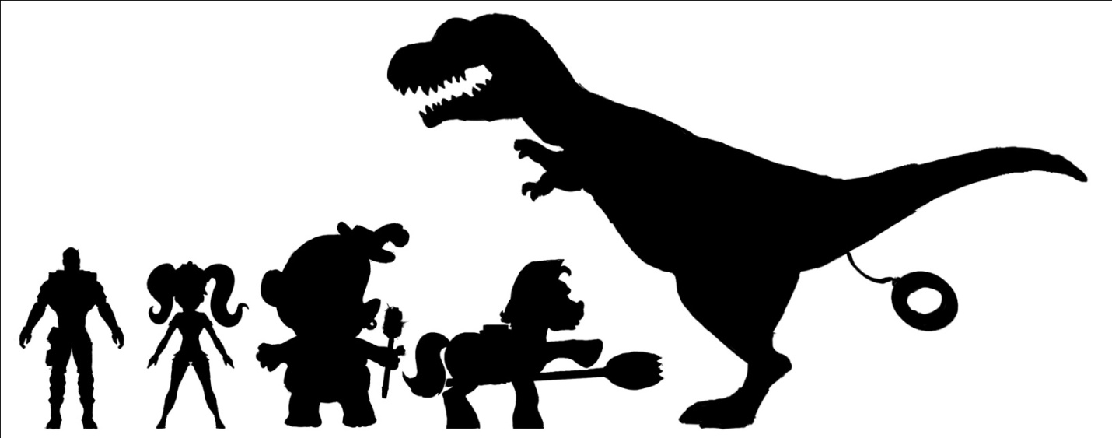

Figure : Example of Scale Chart

#### Unit of Measurement/Scale

Instruction: *The unit of measurement is an internal setting in 3DSMax that must be correctly adjusted in order to work with the technology and engine in use for development. You will need to identify the unit type and create all assets based on this.*

### Font

Instruction: Select a font for the text in the game. The font section identifies the style of font to be used or generated and the reasons why this font correctly identifies and works with the overall game style.

MAGLEV: OCR A EXTENDED

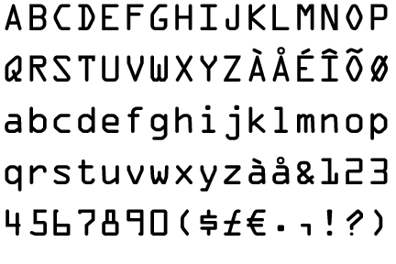

Figure : Example of Font

The OCR A Extended font evokes a robotic look to the text while maintaining readability for the player. This is the main text of the game.

# Asset List

Instruction: Reference the Asset Database listings of all art assets to be created here with a series of hyperlinks to the Asset Database. Include the Asset Dabase.xlsx in the zip folder with the ASG.